Cross-sectional/screening (badanie przekrojowe/ skrinnig)
Explanation, additional information | Content of the lecture
Badanie przesiewowe/skriningowe  Cross-sectional studies | Cross-sectional/screening in medicine is a strategy used in a population to identify an unrecognized disease in individuals without signs or symptoms.
Główne cele  Goals of the screening | Goals of the screening:  - Identification of the high risk person – prevention of the disease  - Detection of the disease of early stage – more effective treatment
Przykłady badań przesiewowych  Examples of effective screening | Examples of effective screening:  - Neonatal screening for phenylocetonuria  - Mammography in women at age > 50 years (high risk groups: 40-50 years)  - Pop-smear tests (cytology) in women at age > 20 years  - Program of cardiovascular disease prevention (NFZ)
Sample selection  Dobór próby | Sample selection:  • Sampling: one stage, multiple stage; after stratification  • Sample size: hypothesis tested, variation, decided significance level, expected result
Przykłady analizy w badaniu skryningowym  Examples of screening test analysis | 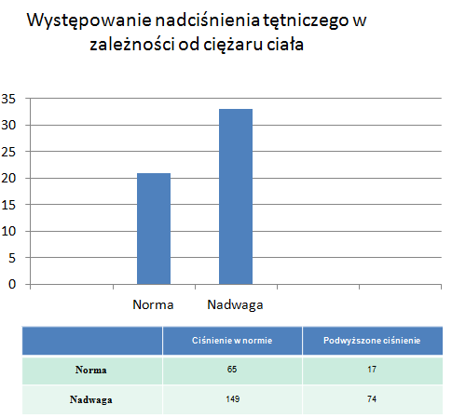  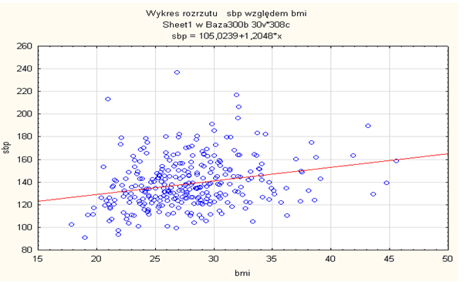
Warunki do wdrożenia skryningu jako metody opieki zdrowotnej  Conditions for the implementation of screening as a method of health care | WHO guidelines (Wilson 1968)  - The condition should be an important health problem  - There should be a treatment for the condition  - Facilities for diagnosis and treatment should be available  - There should be a latent stage of the disease  - There should be a test or examination for the condition  - The test should be acceptable to the population  - The natural history of the disease should be adequately understood  - There should be an agreed policy on whom to treat  - The total cost of finding a case should be economically balanced in relation to medical expenditure as a whole  - Case – finding should be a continuous process, not just a “once and for all” project
Dobór próby  Sample selection | Sample selection:  • Sampling: one stage, multiple stage; after stratification  • Sample size: hypothesis tested, variation, decided significance level, expected result
Wady i zalety badania skryningowego  Advantages and disadvantages of skinning test  Badanie przekrojowe jako badanie naukowe  Cross-sectional study  Projekt badania przekrojowego  Design cross-sectional study | Advantages (positives)  - Allow for studying many exposures  - Allow to study many characteristics of the disease or several diseases/states  - Quality control over all measurements  - Allow to test study hypotheses  - Allow to control confounding  - Allow to assess the dose effect  Disadvantages (negatives)  Less able to prove causation (do not provide direct evidence on the time sequence of the event)
TIME
ill
- exposed (a)
- not exposed (c)

Sample
studied
Study population
healthy
- exposed (b)
- not exposed (d)

Disease
Exposure |  | + | -
 | + | a | b
 | - | c | d  exposed  - ill (a)  - healthy (b)

Sample studied
Study population

not exposed
- ill (c)
- health (d)

VOCABULARY
Cross-sectional studies- badania przekrojowe
Detection- wykrycie
Economically balanced- ekonomicznie uzasadnione, zbalansowane
Examination- badanie diagnostyczne
Exposed- narażona (grupa)
Identification- zidentyfikowanie
Latent- ukryty
Not exposed- nie narażona (grupa)
Prevention of the disease- zapobieganie chorobie
Sample- próba
Sample selection- dobór próby
Screening- badanie skriningowe, przesiewowe
Test- badanie diagnostyczne

